Siddaganga Polytechnic
Batawadi , Tumkur-572103

Department of Computer Science & Engineering


FULL STACK DEVELOPMENT (20CS52I)
A Lab Manual Submitted By
5th Semester
DEPT. OF COMPUTER SCIENCE AND ENGINEERING
UNDER THE GUIDANCE OF
Smt. Meghana G _{B.E (CSE)}
Lecturer in Computer Science & Engineering
Siddaganga Polytechnic.
Tumkur-3
FULL STACK DEVELOPMENT
List of Experiments:-
Sl.no | Experiments
1 | Create User Stories ,Product backlog, workflow and start sprint using appropriate tool like Jira
2. | Creation of local Repository on Git and push it into Remote Repository and  Working with Git Commands
3. | Setting up React environment and Create and running a React.js app
4. | Setting Up the Environment and Tools for front-end development Installing VS Code
5. | Create a form like registration form or feedback form, after submit hide  create form and enable the display section using java script.
6. | Create and run simple program in Typescript
7. | Create and run a simple Maven project
8. | Create a Spring Boot Project in Eclipse IDE
9. | Initialize Spring boot Project
10. | Download and Install MySQL and perform CRUD operation on database
11. | Download and Install MongoDB and perform CRUD operation on database
12. | Create and Run Servlet class using Tomcat server
13. | Download and Install Docker & Execute simple commands in Linux

- Create User Stories ,Product backlog, workflow and start sprint using appropriate tool like Jira
How to create project plan and product backlog for project and User story creation.
- Open browser, search for Jira Login.
- Continue with your Gmail account or login to Jira.
- Click on Jira software and select project from top menu bar then select create project from dropdown Menu.
- Select Scrum click on template and click on create.
- Give a name to your project and Give a Description if you want .
- Click on create.
- Select issues from top menu bar and select issue type .This will be default setting.
- Give a summary to your project.
- Now write a user story in Description box.
- Your story will then go into the backlog to be Assigned and auctioned by the project manager, product owner or other relevant stakeholders and click on start sprint
- Click on Board and select Insights
- Click on Insights and click “Sprint burn down”
- And click on Learn more.

- Create and manage product backlog using appropriate tool like Jira

Summary: Customer registration functionality
Description
AS A customer
I WANT to have registration functionality
SO THAT I can successfully resist
Scope
- build a registration page
- customer validation
- customer should be able to change the phone number
- it should work in all the browser
- it should also work in mobile
Pre condition
- customer should have email and phone number
Acceptance criteria
Scenario 1: customer can successfully resister
- “Given” I am on registration page
- “And” I give valid customer name and phone number
- “And” I check on sing in
- “Then” I will successfully resister
Scenario 2: customer cannot successfully resister
- “Given” I am on registration page
- “And” I give invalid customer name and phone number
- “Then” I will get a error message as “registration failed incorrect customer name”

Summary: Customer checking availability
Description
AS A customer
I WANT to have checking available of hall
SO THAT i can check the available halls
Scope
- build a available checking page
- it should be only inside the Karnataka
- customer should be able to check the available halls in their particular location
pre condition
- customer should have nearest halls in their location
Acceptance criteria
Scenario 1: Customers can successful check availability of hall in their location
- “Given “ I am on check available of hall page
- “And” I give particular location and date

Scenario 2: customer can’t successfully check availability of hall in their location
- “Given “ I am on check available of hall page
- “And” I give wrong location
- “Then” I will get the error message as in valid location

Summary: Customer booking hall
Description
AS A customer
I WANT to booking hall
SO THAT i can book the hall
Scope
- build a booking hall page
- customer should be able to change the date and location
Pre condition
- customer should be able to book the hall in their particular date
Acceptance criteria
Scenario 1: customer can successfully booking hall
- “Given” I am on booking page
- “And” I give available date time
- “And” I will book the hall
- “Then” I successfully booked the hall
Scenario 2: customer can’t successfully booking hall
- “Given” I am on booking page
- “And” I give invalid date and time
- “Then “I will get the error messages as their hall is already booked

Summary: Customer booking details
Description:
AS A customer
I WANT to block the hall
SO THAT I can get the booking details
Scope
- build a booking details page
- it should be able to see after the booking also
- customer should be able to change details if their want
Pre condition
- customer have to fill the every information given in the booking details
Acceptance criteria
Scenario 1: customer can successfully get the booking details
- “Given” I am on the booing details page
- “And” I fill the details
- “And” I have also blocked the hall
- “Then” I will successfully get the booing details
Scenario 2: customer will not get the booking details
- “Given” I am on the booking details page
- “And” I will fill the details without blocking hall
- “Then” I will get a error message as the hall is not blocked yet

- Create Sprint 1 with required user stories
Note: Create user story for required topic and follow the steps below.
- Give a summary to your project.
- Now write a user story in Description box.
- Your story will then go into the backlog to be Assigned and auctioned by the project manager, product owner or other relevant stakeholders and click on start sprint
- Click on Board and select Insights
- Click on Insights and click “Sprint burn down” And click on Learn more.

2.Creation of local Repository on Git and push it into Remote Repository and
Working with Git Commands
Create repository – named mini project-1 Push and pull operation in GitHub.
- Browse to the official Git website: https://git-scm.com/downloads
- Click the download link for Windows and allow the download to complete.
- Double-click the file to extract and launch the installer.
Git operations

Creating a repository
- Open browser, search for GitHub Login.
- Sign in with your username and password
- In the upper-right corner, use the drop-down menu, and select New repository.
- Give a name for your repository. For example, "hello-world".
- Add a description of your repository. For example, "Mini Project I"
- Click Create repository.
Push Operation:
- Go to add files and select upload files.
- Choose your files then select a file or folder click on open.
- Click on commit changes.
Clone or pull operation:
- Click on code dropdown button
- Click on Download Zip
Working with Git Commands
Git clone
- Git clone is a command for downloading existing source code from a remote repository (like Github, for example). In other words, Git clone basically makes an identical copy of the latest version of a project in a repository and saves it to your computer.
- Syntax : git clone https://name-of-the-repository-link
Git branch
- Branches are highly important in the git world. By using branches, several developers are able to work in parallel on the same project simultaneously. We can use the git branch command for creating, listing and deleting branches.
- Creating a new branch:
- Syntax : git branch <branch-name>
Git checkout
- This is also one of the most used Git commands. To work in a branch, first you need to switch to it. We use git checkout mostly for switching from one branch to another. We can also use it for checking out files and commits.
Syntax:
- git checkout <name-of-your-branch>
Git status
- The Git status command gives us all the necessary information about the current branch.
- Syntax: git status
Git add
- When we create, modify or delete a file, these changes will happen in our local and won't be included in the next commit (unless we change the configurations).
- To add a single file:
- git add <file>
- To add everything at once:
- git add -A
Git commit
- This is maybe the most-used command of Git. Once we reach a certain point in development, we want to save our changes (maybe after a specific task or issue).
Syntax :
- git commit -m "commit message"
Git push
- After committing your changes, the next thing you want to do is send your changes to the remote server. Git push uploads your commits to the remote repository.
Syntax
- git push <remote> <branch-name>
Git pull
- The git pull command is used to get updates from the remote repo. This command is a combination of git fetch and git merge which means that, when we use git pull, it gets the updates from remote repository (git fetch) and immediately applies the latest changes in your local (git merge).
- Syntax
- git pull <remote>

Git revert
- Sometimes we need to undo the changes that we've made. There are various ways to undo our changes locally or remotely (depends on what we need), but we must carefully use these commands to avoid unwanted deletions.
Syntax
- git revert 3321844
Git merge
- When you've completed development in your branch and everything works fine, the final step is merging the branch with the parent branch (dev or master). This is done with the git merge command.
- Git merge basically integrates your feature branch with all of its commits back to the dev (or master) branch. It's important to remember that you first need to be on the specific branch that you want to merge with your feature branch.

For example, when you want to merge your feature branch into the dev branch:
- First you should switch to the dev branch:
- git checkout devBefore

- merging, you should update your local dev branch:
- git fetchFinally
- you can merge your feature branch into dev:
- git merge <branch-name>
- Branches are highly important in the git world. By using branches, several developers are able to work in parallel on the same project simultaneously. We can use the git branch command for creating, listing and deleting branches.
- Creating a new branch:
Syntax : git branch <branch-name>
- Git checkout
- This is also one of the most used Git commands. To work in a branch, first you need to switch to it. We use git checkout mostly for switching from one branch to another. We can also use it for checking out files and commits.
- Syntax:
- git checkout <name-of-your-branch>

Git status
- The Git status command gives us all the necessary information about the current branch.
- Syntax: git status
Git add
- When we create, modify or delete a file, these changes will happen in our local and won't be included in the next commit (unless we change the configurations).
- To add a single file:
- git add <file>
- To add everything at once:
- git add -A
Git commit
- This is maybe the most-used command of Git. Once we reach a certain point in development, we want to save our changes (maybe after a specific task or issue).
- Syntax :
- git commit -m "commit message"
Git push
- After committing your changes, the next thing you want to do is send your changes to the remote server. Git push uploads your commits to the remote repository.
- Syntax
- git push <remote> <branch-name>

- Git pull
- The git pull command is used to get updates from the remote repo. This command is a combination of git fetch and git merge which means that, when we use git pull, it gets the updates from remote repository (git fetch) and immediately applies the latest changes in your local (git merge).
- Syntax
- git pull <remote>
Git revert
- Sometimes we need to undo the changes that we've made. There are various ways to undo our changes locally or remotely (depends on what we need), but we must carefully use these commands to avoid unwanted deletions.
- Syntax
- git revert 3321844
Git merge
- When you've completed development in your branch and everything works fine, the final step is merging the branch with the parent branch (dev or master). This is done with the git merge command.
- Git merge basically integrates your feature branch with all of its commits back to the dev (or master) branch. It's important to remember that you first need to be on the specific branch that you want to merge with your feature branch.
- For example, when you want to merge your feature branch into the dev branch:
- First you should switch to the dev branch:
- git checkout devBefore
- merging, you should update your local dev branch:
- git fetchFinally
- you can merge your feature branch into dev:
- git merge <branch-name>

- Setting up React environment and Create and running a React.js app

React Introduction
ReactJS is a declarative, efficient, and flexible JavaScript library for building reusable UI components.
It is an open-source, component-based front end library responsible only for the view layer of the application.
It was created by Jordan Walke. It was initially developed and maintained by Facebook and was later used in its products like WhatsApp & Instagram.
REACT FEATURES:
Currently, ReactJS gaining quick popularity as the best JavaScript framework among web developers. It is playing an essential role in the front-end ecosystem. The important features of ReactJS are as following.

- JSX: JSX stands for JavaScript XML. It is a JavaScript syntax extension. Its an XML or HTML like syntax used by ReactJS. This syntax is processed into JavaScript calls of React Framework.
- Components:ReactJS is all about components. ReactJS application is made up of multiple components, and each component has its own logic and controls. These components can be reusable which help you to maintain the code when working on larger scale projects.
- One-way Data Binding:ReactJS is designed in such a manner that follows unidirectional data flow or one-way data binding. The benefits of one-way data binding give you better control throughout the application
- Virtual DOM:A virtual DOM object is a representation of the original DOM object. It works like a one-way data binding
- Simplicity:ReactJS uses JSX file which makes the application simple and to code as well as understand.
Performance: when we create a component, we did not write directly to the DOM. Instead, we are writing virtual components that will turn into the DOM leading to smoother and faster performance.

Setting up React environment
Create and run simple program in React.
- Open any browser search node.js, Install LTS version.
- Setup node.js, make sure that the node.js have installed by giving command in cmd
    - node –v
    - tsc -v
- Create a directory by giving command mkdir <directory name> change directory to created directory.
- To create react app by giving the command
    - npx create-react-app <app name>
    - cd <app name>
    - npm start
NPM is a package manager which starts the server and access the application at default server http://localhost:3000. Now, we will get the following screen.
- Open visual studio code and follow the same steps to run the react app
Run a simple program in react.js app and show output in the browser.

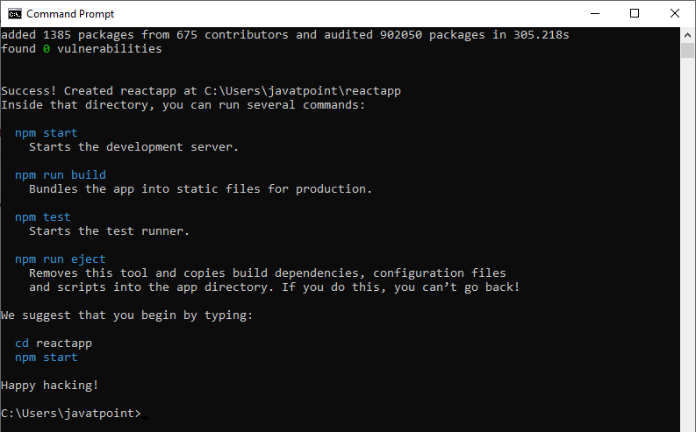

The above screen tells that the React project is created successfully on our system. Now, we need to start the server so that we can access the application on the browser. Type the following command in the terminal window.
1. $ cd reactapp
2. $ npm start
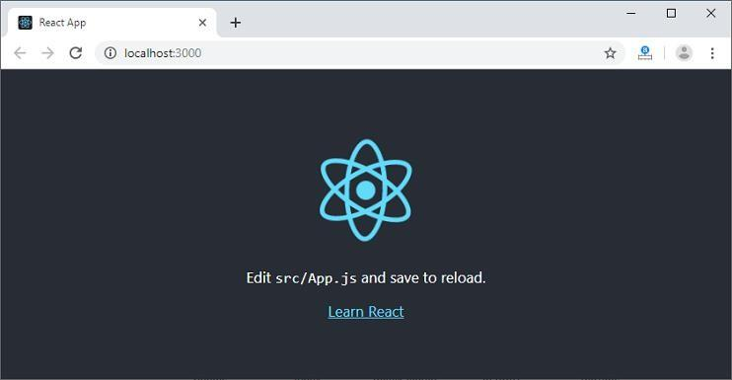
NPM is a package manager which starts the server and access the application at default server http://localhost:3000. Now, we will get the following screen.

4.Setting Up the Environment and Tools for front end development Installing VS Code
VS Code is a free code editor that runs on Windows, Mac and Linux.
Download VS Code from https://code.visualstudio.com/.

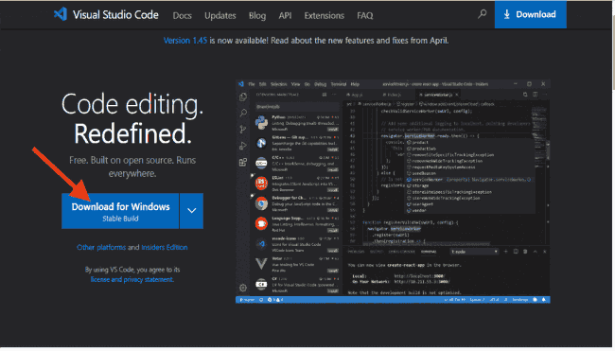

Install Visual Studio Code by opening the downloaded setup file and following the prompts.

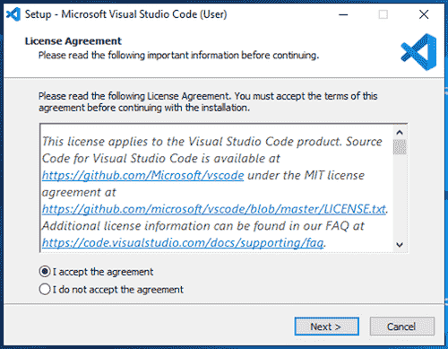

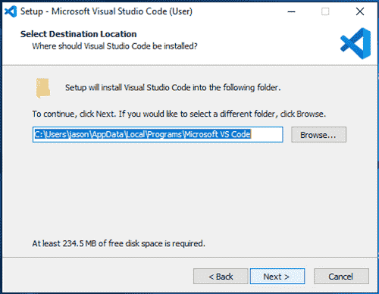
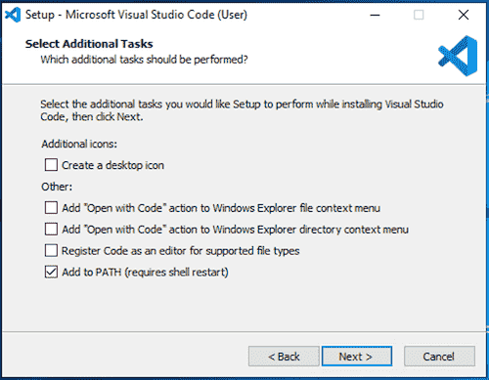

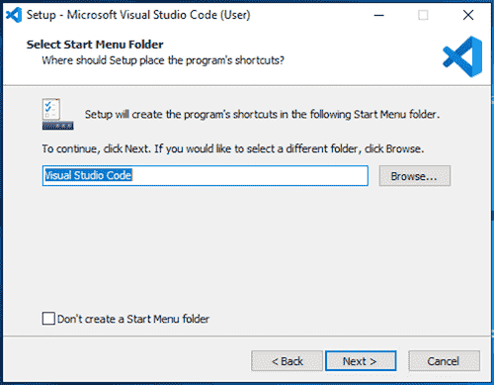
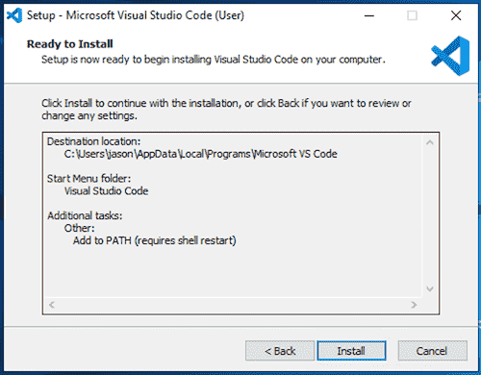

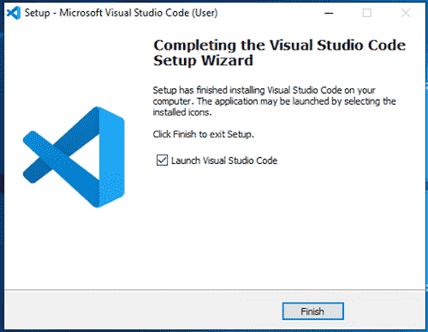
5.Create a form like registration form or feedback form, after submit hide
create form and enable the display section using java script.

Registration.html
<html> <head>
<title> Registration Form</title>
<script>
function passvalues()
{
var name = document.getElementById("name").value;
var email = document.getElementById("email").value;
var address = document.getElementById("address").value;
localStorage.setItem("name",name);
localStorage.setItem("email",email);
localStorage.setItem("address",address);
return;
}
</script>
</head>
<body>
<h1>Registrtion Form</h1>
<form action="Details.html">
<fieldset>
<legend>Registration</legend>
<label> Name </label>
<input type="text" id="name"/><br><br>
<label> Email ID </label>
<input type="email" id="email"/><br><br>

<label> Address </label>
<input type="address" id="address"/><br><br>
<input type="submit" value="submit" onclick="passvalues()"/>
</fieldset>
</form>
</body>
</html>

Details.html
<html>
<head>
<title> Details</title>
</head>
<body>
<form>
Your Name is:<p id="name"></p><br>
Your email is:<p id="email"></p><br>
Your address is:<p id="address"></p>
<script>
document.getElementById("name").innerHTML = localStorage.getItem("name");
document.getElementById("email").innerHTML = localStorage.getItem("email");
document.getElementById("address").innerHTML = localStorage.getItem("address");

</script>
</form>

</body>
</html

Create and run simple program in TypeScript

Install TypeScript using Node.js Package Manager (npm)
Step-1 Install Node.js. It is used to setup TypeScript on our local computer.
To install Node.js on Windows, go to the following link: https://www.javatpoint.com/install-nodejs

Step-2 Install TypeScript. To install TypeScript, enter the following command in the Terminal Window.
- npm install typescript --save-dev //As dev dependency
- npm install typescript -g //Install as a global module
or
- npm install -g typescript
- npm install typescript@latest -g //Install latest if you have an older version

Step-3 To verify the installation was successful, enter the command $ tsc -v in the Terminal Window.
Install Live server
npm install -g live-server

Create and run first program in TypeScript
- open command prompt
- go to d: drive(any drive)
- d:\>mkdir typescript
- d:\>cd typescript
- d:\typescript> npm install typescript --save-dev
- open visual studio code
- file-open folder-choose typescript folder from d:
- create new file- save it as types.ts(any name.ts)
- Write the below code and save it
- console.log("Hello World");
- go to command prompt and compile the program
- tsc types.ts
- run the program
- node types.js
- Observe the output

Example:
if-else:
var age=18;
if(age>=18)
{
console.log("You are eligible for voting");
}
else{
console.log("You are not eligible for voting");
}

OR
while:
let counter = 0;
while (counter < 5) {
console.log(counter);
counter++;
}
- Create and run simple program in Apache Maven
- Maven is a Java based tool, so the very first requirement is to have JDK installed on your machine.
- To install maven on windows, you need to perform following steps:
  - Download maven zip file and extract it.
  - Add JAVA_HOME in user variables environment.
  - Add maven bin directory and JDK path to system variables environment.
  - Verify Maven in CMD by the following command.
    - mvn –version
- Open Eclipse. Select File > Other > Maven. Select Maven Projects Option. Click on Next Button.
- Select create a simple project and click next
- Give group id and artifact id and click on finish
- Then run a simple java program.
public class Demo{
public static void main(String[] args) {
int a = 3;
int b = 5;
int sum = a+b
System.out.println(“The sum is”+sum);
}
}

8. Create a Spring Boot Project in Eclipse IDE
- Open the Spring Initializr https://start.spring.io/.
- Select the Spring Boot version 3.0.11 BUILD-SNAPSHOT.
- Provide the Group name. We have provided the Group name com.javatpoint.
- Provide the Artifact. We have provided the Artifact spring-bootapplication-run.
- Add the Spring Web dependency.
- Click on the Generate button. When we click on the Generate button, it wraps all the specifications related to application into a Jar file and downloads it to the local system.
- Extract the jar file.
- Go to file > Open Projects from file system > Browse extracted directory import it into import source.
- And at last click on the Finish button and we are done creating the Spring Boot project.
- By now, Spring Boot project has been created as depicted in the below media.

Spring Version:
Step 1: Install Eclipse IDE for Enterprise Java and Web Developer Please refer to this article How to Install Eclipse IDE for Enterprise Java and Web Development and install the Eclipse IDE.
Step 2: Create a Spring Boot Project in Spring Initializr Go to this link and create a Spring Boot project. Please fill in all the details accordingly and at last click on the GENERATE button below. This will download your Spring Boot project in zip format. Now extract the folder into your local machine.
Step 3: Import Spring Boot Project in Eclipse IDE Go to the Eclipse IDE for Enterprise Java and Web Developer > File > Import as shown in the below image.
Step 4: Search “maven” and choose Existing Maven Project and click on the Next button as shown in the below image.
Step 5: Now click on the Browse button and select the extracted zip file that has been generated. Step 6. And at last click on the Finish button and we are done creating the Spring Boot project.
By now, Spring Boot project has been created as depicted in the below media
9. Initialize Spring boot Project
package com.example.demo;
import java.util.*;

import org.springframework.boot.SpringApplication;
import org.springframework.boot.autoconfigure.SpringBootApplication;

@SpringBootApplication
public class DemoApplication {
public static void main(String[] args) {
Scanner c = new Scanner(System.in);
System.out.println("enter the number for a=");
int a= c.nextInt();
System.out.println("enter the number for b");
int b= c.nextInt();
System.out.println(a+b+" is the sum");
}
}

10. Download And Install MySql and perform CRUD operation in MySql.
- Open the MySQL website on any Browser.
- Select the Download option.
- Select MySQL Installer for Windows
- Choose the desired installer and click on download.
- After download open installer.
- Click Yes, it asks to choose setup area. Select custom and Click Next.
- Open MySQL. Select the server you want to install, and move it to products button.
- Click on Next > execute to download and install MySQL Server, shell and workbench
- Once the product is ready to configure, click Next. Under Type and Networking. Click Next.
- For authentication use password
- Select MySQL on Most Root password and click on next.
- Go for default windows, under apply configuration click on execute, and click on finish.
- Complete the installation. This will launch MySQL Workbench and shell.
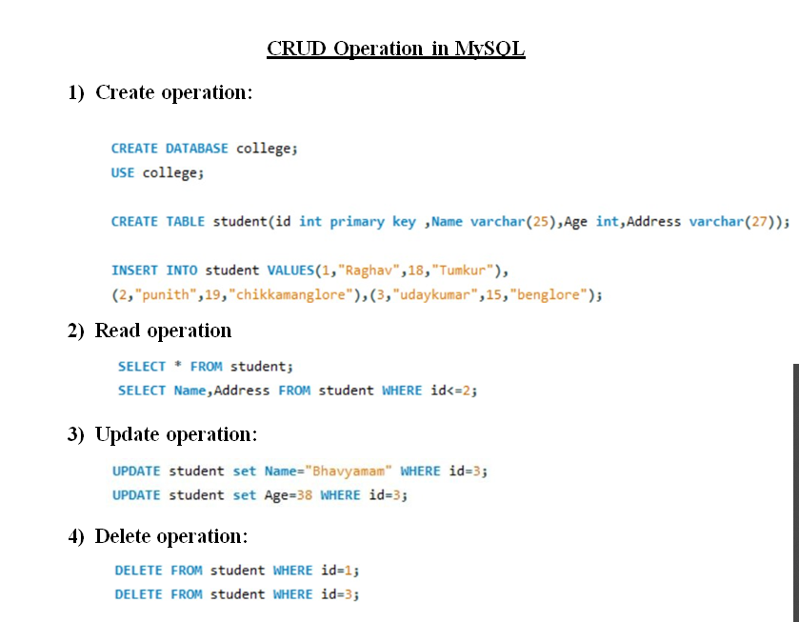
11. Download and Install MongoDB and perform CRUD operation on database
- Go to browser and download mongoDb community server (https://www.mongodb.com/try/download/community a)
- Once download is complete open the msi file. Click Next in the start up screen
- Accept the End-User License Agreement > Click Next
- Click on the “complete” button
- Click on the “complete” button to install all of the components.
- Select “Run service as Network Service user”. make a note of the data directory, we’ll need this later > Click Next
- Click on the Install button to start the installation.
- Once complete the installation, Click on the Finish button.

MangoDB Shell
  - To install the new MongoDB shell (mongosh), visit www.mongodb.com and click on Product menu -> Tools -> Database Shell, as shown below.
  - On the MongoDB Shell page, click on the Download button to download the shell.
  - Now, click on the downloaded installer file to start the installation wizard and click on next.
  - Click on the Install button to start the installation. It should quickly install it click on finish button
  - Click on the mongosh.exe to open a new MongoDB shell and Press Enter to start the shell,

CRUD Operation in MongoDB Shell
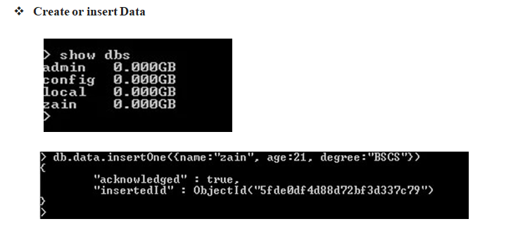
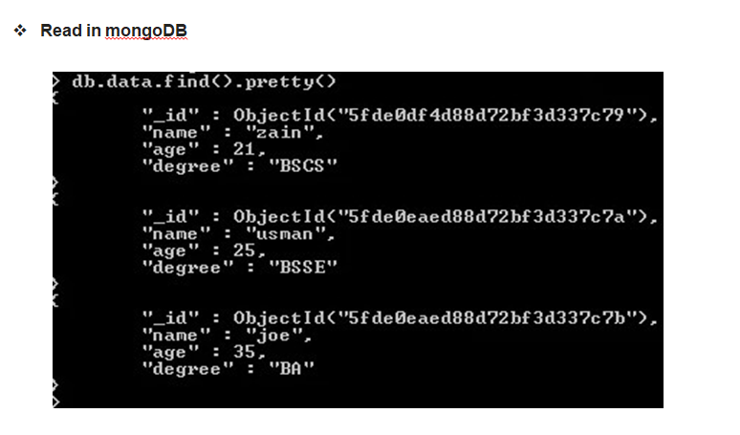
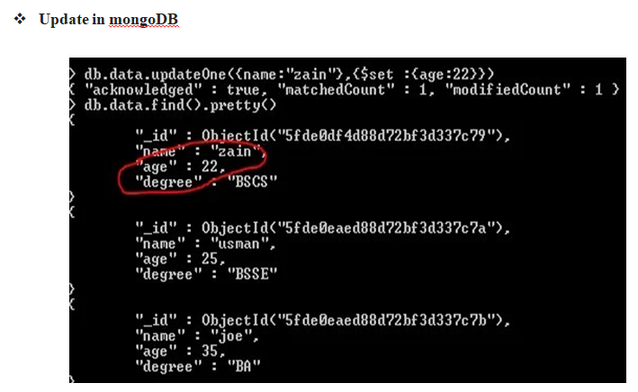

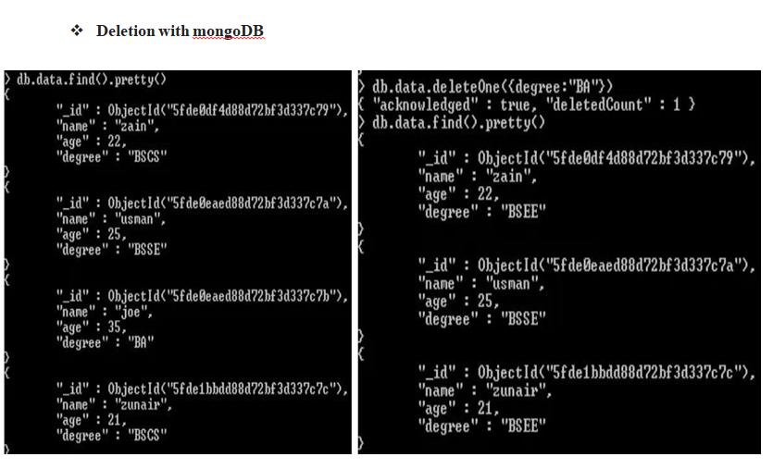
12. Create and Run Servlet class using Tomcat server
- Apace Tomcat
- Open any Browser and search Apache Tomcat website, click on Tomcat 10 and download 32-bit/64-bit Windows Service Installer
- Go to downloads, open the file and click next to proceed > read the license agreement and click on I agree > in components selection select full and click next.
- Give the username and password and click next > and select where the folder should be installed and click on install.
- Open Eclipse, go to help > install new software > in (work – with) box select all available sites.
- Click on Web, XML, Java EE and OSGi Enterprise development and click next > accept the agreement > and click on finish.
- It will ask to restart eclipse, click on restart.
- Click on open perspective on the top right corner of eclipse > select Java EE and click open.
- Go to server and click on add server > in define a new server click on apace > select latest version of tomcat server and click next, here browse for the directory you need to install the server > OK > Finish.
- Go to file > new > Dynamic web project > Enter the project name and keep the rest of the settings as it is and click next, select Generate web.xml deployment descriptor and click on finish, web project will be generated.
- Create a servlet class, go to file > new > servlet. Enter java package name and class name, click next > Deployment descriptor (web.xml) can be specified if required > click next and finish.
- Configurations will be generated in eclipse editor, change the description as required and run the servlet code.
- To run the code right click on the servlet > run as > run on server > select to run on existing server and select the server on which the code should be executed > next > finish.
- To restart the server and to run the application click ok and output will be displayed.
13. Download and Install Docker & Execute simple commands in Linux.

Docker Installation Steps
- For installation of Docker, go to browser and search for Docker download. And click on the first link that appears.
- After clicking the link, choose your OS, be it Windows, MAC, or Linux for installation.
- After installation, Open the Docker Desktop.
- Accept the Docker Subscription Service Agreement window. and click On continue. Docker Desktop will start after we accept the terms and conditions.
- After installation it will ask to restart your computer click on restart.
- Open docker desktop then run git bash as administrator and execute the following commands.
Commands for docker
- To verify docker is installed or not
- docker
- To check version of docker
- docker version
- To run built in container of docker
- docker run hello-world
- To run ubuntu in docker
- docker pull ubuntu
- docker run -it -d ubuntu
- docker ps -a
- winpty docker exec -it <id of ubuntu container> bash
# mkdir spt // to create directory
# cd spt // to change directory
# cat > demo // to create a file
# cat demo (or) echo demo // to display contents of file
# rm demo // to delete a file
# rmdir spt // to delete directory
- To stop the running container
- docker stop <Container Id>
- To remove the running container
- docker remove <Container Id>

